Name:_________________________________________

Teacher: _______________________________________

Class: ____________________________

CC Number: _____________________________

MATHEMATICS

YEAR 10 EXAM
PATHWAY TWO

SEMESTER ONE 2015

Section Two: Resource Allowed

TIME ALLOWED FOR THIS PAPER
Reading time before commencing 5 minutes.
Working time for paper 55 minutes.

MATERIAL(S) REQUIRED / RECOMMENDED FOR THIS PAPER
TO BE PROVIDED BY THE CANDIDATE:
Standard items: pens, pencils, pencil sharpener, eraser, correction fluid, ruler, highlighters.

Special items: Calculator, 1 x A4 sheet of notes, Formula Sheet

Important note to candidates:
No other items may be used in this section of the examination. It is your responsibility to ensure that you do not have any unauthorised notes or other items of a non-personal nature in the examination room. If you have any unauthorised material with you, hand it to the supervisor before reading any further.
TO BE PROVIDED BY THE SUPERVISOR:
This Question / Answer Booklet
Formula Sheet
Instructions to candidates
- Candidates are to remain seated during the exam and are not allowed to talk to other candidates.
- Mobile phones are not to be used at all during the exam.
- Students who fail to follow examination rules will be removed and dealt with in accordance to the schools policy.

Write your answers in the spaces provided in this Question/Answer Booklet. Spare pages are included at the end of this booklet. They can be used for planning your responses and/or as additional space if required to continue an answer.
- Planning: If you use spare pages for planning, indicate this clearly at the top of the page
- Continuing an answer: If you need the space to continue an answer, indicate in the original answer space where the answer is continued, i.e. give the page number. Fill in the number of the question(s) that you are continuing to answer at the top of the page.

Show all your working clearly. Your working should be sufficient to allow your answers to be checked readily and for marks to be awarded for reasoning. Incorrect answers given without supporting reasoning cannot be allocated any marks. For any question or part question worth more than two marks, valid working or justification is required to receive full marks. If you repeat an answer to any question, ensure that you cancel the answer you do not wish to have marked.

Use a blue or black pen only, except with diagrams where you should use pencil.

Question | Out of | Mark
17 | 1
18 | 1
19 | 1
20 | 1
21 | 6
22 | 6
23 | 6
24 | 6
25 | 5
26 | 8
27 | 6
28 | 3
29 | 9
TOTAL | 59
 | Mark
Percentage

- Find 16% of $500. (Choose the correct answer)
A $40 B $80 C $120 D $160

(1 mark)

- Find the median of the following numbers. (Choose the correct answer)
5 5 7 8 10 12 16 16 16 20
A 10 B 11 C 11.5 D 16

(1 mark)

- If Jennifer borrows $2000 and has to pay back $2400, what is the percentage rate of interest? (Choose the correct answer)

A 1.7% B 20% C 40% D 120%

(1 mark)

- Mikhail buys a very rare stamp worth $8500. It is expected to increase in value by 15% each year. What to the nearest $100 will its value be in 5 years time? (Choose the correct answer)

A $14 400 B $15 600 C $16 700 D $17 100

(1 mark)
- Factorise the following expressions

  - $5x^{2}-10x=5x(x-5)$
Could also accept $5\left(x^{2}-2x\right)or x(5x-10)$since question does not say fully factorise

  - $x^{2}+8x-20=(x-2)(x+10)$

  - $x^{2}-x-20=(x-5)(x+4)$

(6 marks)

- Greg has $25 000 to invest. Show all working.

Option 1: He can invest it for 6 years at a simple interest rate of 10%.

Option 2: He can invest it for 5 years at a rate of 10%, compounding 6 monthly.

- Which option gives Greg the greatest return for his investment? Why?
Option 1 - $25000×0.1×6=15000$
Option 2 – ${25000×\left(1.05\right)}^{10}=40722.37$
$40722.37-25000=15722.37$
Option 2 – Valid reason

- How much more money will he make with the best investment, than with the other option?
$\$722.37$

(6 mark)

- Use the compound interest formula to compare the interest on $10 000 at 12%pa over 4 years compounded:

  - Annually:

$$10{000×1.12}^{4}=15735.19$$

  - Monthly:

$$10{000×1.01}^{48}=16122.26$$

  - Weekly.

$$10{000×(1+\frac{.12}{52})}^{208}=16151.81$$

(6 marks)
- Simplify the following expressions and write your answers using positive powers.

- $3a^{2}b^{3}×5a^{7}b=15a^{9}b^{4}$

- $(x^{-12}y^{-1})^{-3}×(x^{4}y^{-3})^{5}=x^{36}y^{3}×x^{20}y^{-15}=\frac{x^{56}}{y^{12}}$

- $\frac{25p^{4}q^{-3}}{625p^{4}q^{-7}}=\frac{q^{4}}{25}$

(6 marks)
- Substitute the given values into the following formulas to determine $x$ :

- $y=x+3$ if $y=17$

$$x=14$$

- $y=a+xb$ if $y=362, a=17, b=15$

$362=17+15x$
$$x=23$$

- $y= \sqrt{\frac{x}{a}}$ if $y=6, a=23$

$6=\sqrt{\frac{x}{23}}$

$$x=138$$

(5 marks)
- The number of bottles of wine sold in a restaurant each day for two weeks was divided into white wine and red wine sales.

• Number of bottles of white wine sold:
9, 16, 15, 20, 32, 20, 23, 8, 9, 35, 19, 20, 24, 19
8, 9, 9, 15, 16, 19, 19, 20, 20, 20, 23, 24, 32, 35
• Number of bottles of red wine sold:
9, 9, 8, 12, 14, 8, 10, 6, 6, 18, 8, 11, 11, 10
6, 6, 8, 8, 8, 9, 9, 10, 10, 11, 11, 12, 14, 18
  - Find the quartiles and medians for both sets of data and display this information as stacked box and whisker plots.

White - $Q_{1}=15 Q_{2}=19.5 Q_{3}=23$($\frac{1}{2} each)$

Red - $Q_{1}=8 Q_{2}=9.5 Q_{3}=11$($\frac{1}{2} each)$

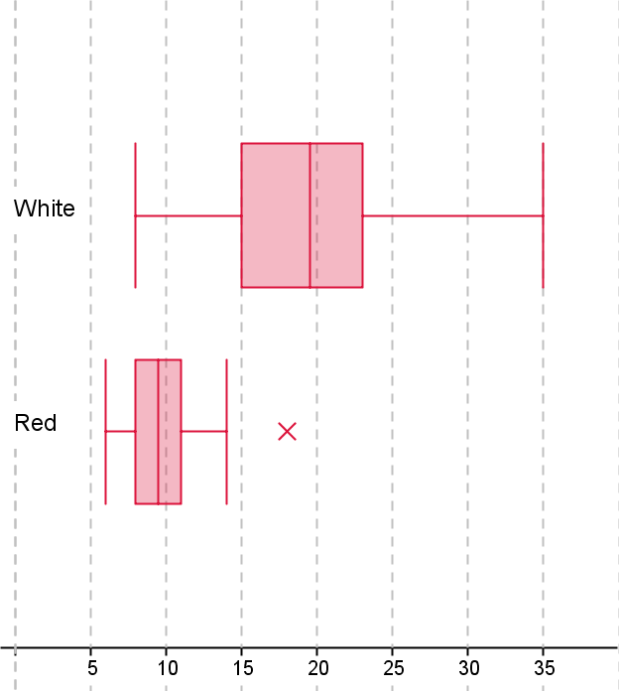

Scale accurate white plotaccurate red plotuses same scale

(7 marks)

  - Use the boxplots to compare the two data sets.

Correct comparison

(1 marks)

- Expand and simplify the following expressions:

- $\left(6-3p\right)\left(6+3p\right)=36-9p^{2}$

- $\left(3u+2\right)\left(u-3\right)+\left(3u-5\right)\left(u-4\right)=3u^{2}-7u-6+3u^{2}-17u+20$
$=6u^{2}-24u+14$

- $\left(9e+4z\right)\left(7e+4z\right)-\left(7e+9z\right)\left(e-5z\right)$
$$={63e}^{2}+64ez+16z^{2}-7e^{2}+26ez+45z^{2}$$
$$=56e^{2}+90ez+61z^{2}$$

(6 marks)

- Find an expanded and simplified expression for the area of the following triangle.

$\frac{2b+1}{6}$

$\frac{3b-2}{5}$

$$=\frac{1}{2}×\frac{2b+1}{6}×\frac{3b-2}{5}=\frac{6b^{2}-b-2}{60}$$

(3 marks)

- The table below shows the ages of 10 Journalists and the number of flights undertaken to remote locations each year to cover special news stories.

Age | 52 | 45 | 33 | 35 | 28 | 43 | 55 | 63 | 51 | 36
No.of flights | 8 | 12 | 15 | 13 | 10 | 8 | 5 | 3 | 6 | 12

- On the axes provided draw a scatter-plot of this data. ($-\frac{1}{2}$per error) (4 marks)
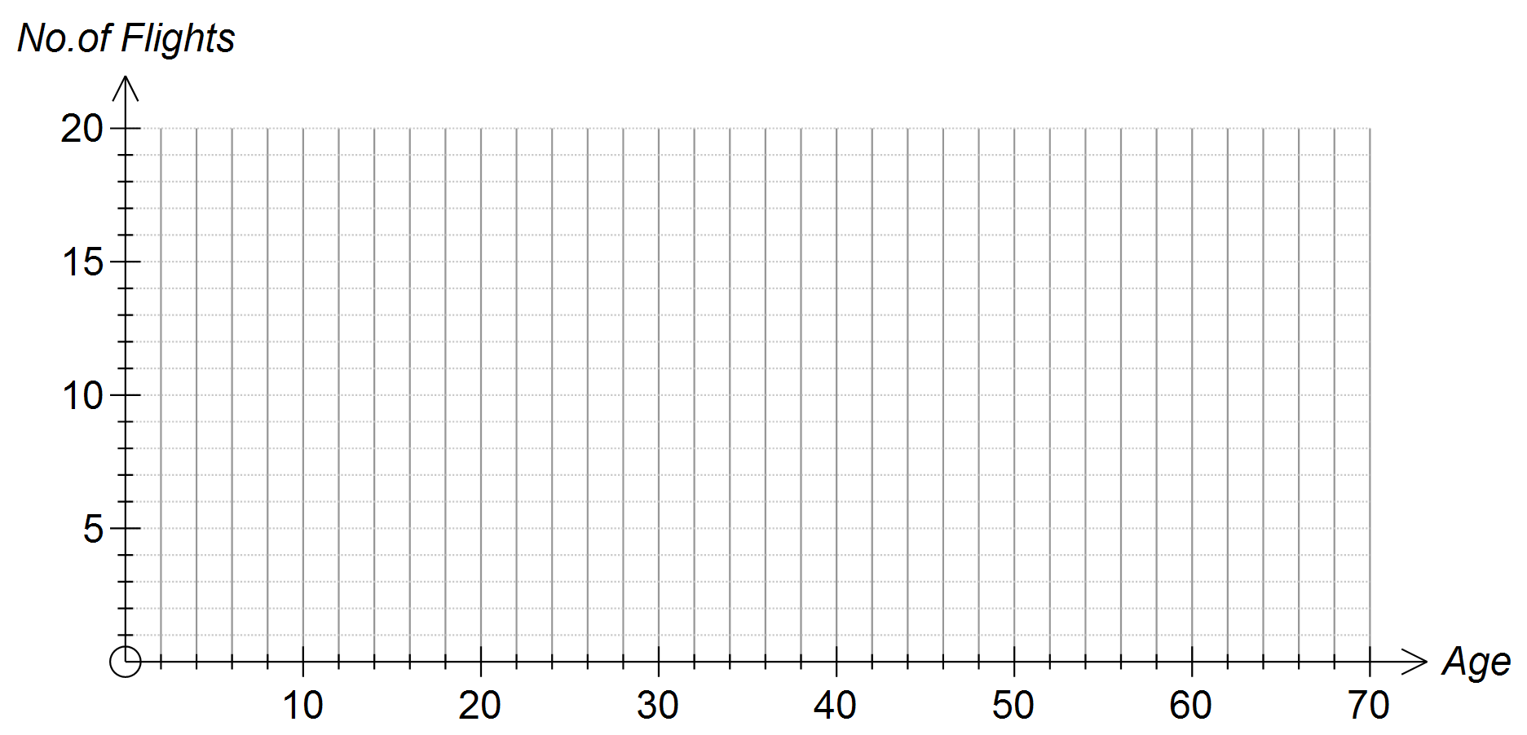
- Describe clearly the strength and direction of the linear relationship show in your scatter-plot. (2 marks)
Weak negative
- On the graph, draw in the line of best fit on the axes provided. (1 mark)
Line

- Use the line you drew to predict the number of flights undertaken by a 19 year old Journalist.
Show clearly on the scatter-plot above how you obtained your answer. (2 marks)
Answer given from line drawn
Shown on the graph

End of Paper

